**APPENDIX**

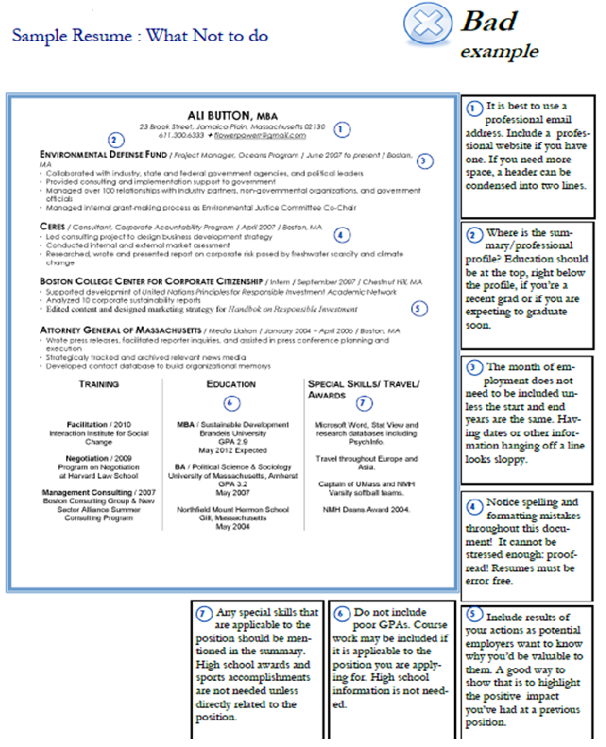



**SPENCER TRAN**

335 Windhover Drive, Richmond Hill, ON, L3R 4N7

[stran@mymail.com](mailto:stran@mymail.com) | Cell:(555)867-5309

PROFESSIONAL SUMMARY

Financial change-agent and recent graduate looking for projects in Treasury Management and Risk Management with a secure and growing company. Hold seven months of work experience at a well-respected local company. Learned how to be a quick learner and highly energetic with the base knowledge of skills needed to perform the tasks and the training to continue to higher positions.

PROFESSIONAL EXPERIENCE

Financial Advisor Fall 2012 - Spring 2013

Jungle Jims West Chester, ON

* Developed asset allocation strategies and formed proprietary investment models for client portfolios.
* Introduced strategic alternatives for current assets and lending services as well as qualified plan solutions and corporate 529 plans for the company.
* Completed comprehensive portfolio reviews to reassess objectives and projected portfolio performance.
* Supervised marketing enterprises including website maintenance, newsletter, print ads and client events.
* Featured speaker at monthly retail and institutional seminars for clients.

Administrative Assistant Summer 2011, Summer 2012

Miami Market Meaford, ON

* Managed administrative needs of four full-time employees and six part-time employees by writing professional correspondence, answering business calls and recording meeting minutes.
* Acted as the first point of contact between the public and the company.
* Maintained records and files and updated the organization system to make it more efficient and cut processing time by 12 percent.

Education

Bachelor of Science in Finance, Ohio State University, Columbus, OH May 2013

3

**Entry Level Finance Resume**

This finance resume is from a recent graduate with little professional experience but does a great job highlighting her transferable accomplishments.

Since the writer of this resume has recently graduated with a bachelor's degree, she does not have much experience. Still, it is important when writing a finance resume to try and detail as much as possible one's experience and developed skills. For this reason, the writer of this resume included a “professional competencies” section where she highlighted her knowledge in specific financial areas such as financial modeling and risk assessment. This would also be a good place to put any computer programs or technologies the applicant is effective in.

Much like a business resume, it is important to quantify one's experience. It does little for the employer if an applicant says “cut processing time.” However, since the writer of this resume specified that she cut processing time by “12 percent,” the employer now understands the success and results of the experience the applicant participated in, and that the applicant is results-oriented. Though she has little experience and is looking for an entry-level finance position, it is important that she only concentrates on relevant work experience and detailed those results with specific measurements and professionalism.

This sample resume is part of the InternationalStudent.com Resume Writing Center.



**Sample Career Transition - Sales Resume**

This is an example of a transitional resume from teaching to sales, specifically from teaching biology to selling pharmaceutical drugs.

# Andrew Smith

450 Hampton Dr., Tampa, FL, 32303  
Phone: 850-555-9867 Email: KevinLong@googlemail.com

## Objective

To use my background in Biology and education to transition from teaching Biology to informing doctors of innovative, new drugs as a Pharmaceutical Sales Representative in the state of Florida.

## Qualifications Summary

I’ve attained a Bachelor’s of Science in Biology, have taught high school Biology and Chemistry, and have had extensive experience in telemarketing during my undergraduate career. With these combined skills, I sought after and completed my (CNPR) Certified National Pharmaceutical Representative and am pursuing an entry level position as a Pharmaceutical Sales Representative.

**Highlights of Qualifications**

* 4 years of professional customer service and sales experience
* 4 years of educating individuals in biology of the body and chemistry
* Microsoft Excel, Microsoft Word and Microsoft PowerPoint
* Excellent written and verbal skills
* Certified National Pharmaceutical Representative
* Florida Teacher Certification

## Experience

Biology and Chemistry Teacher 2010-2014

**Blake High School**

* Organized and prepared lecture classes
* Created interactive and hands on experiments for students
* Created and administered biology and chemistry exams
* Oversaw the Bio/Chem club for participating students

Telemarketer 2006-2010

**Homes.com**

* Sold web-pages to real estate clients seeking to improve their online marketing
* Discussed progress of client sites over phone appointments
* Persuaded clients to purchase new upgrades for sites
* Handled and fixed website errors and system glitches

## Education Bachelor’s of Science, Biology, **University of South Florida**, Tampa, Florida 2010

Tips for writing a career transition to sales:

For all resumes, you will want to begin with your name and contact information and keep the resume format simple, clean, and organized by remaining consistent with the formatting you choose.

In career transition resumes, it is important to include a section called “qualifications summary” so that you can list skills, experience, or qualifications that make you qualified for the job you are transition to. Here is where you will bridge the gap and include how your unique background experience has prepared you for the position.

This sample resume is part of the InternationalStudent.com Resume Writing Center.

**AMY SMITH**

123 Main Street • Dartmouth, Nova Scotia • N4J 2B8

Home: (555) 555-1234, Cell: (555) 555-1235 asmith@sample~resume.com

In this sample resume, the candidate has used the “Summary of Qualifications”, “Clinical Experience” and “Relevant Academic Projects” section to highlight their skills in **DENTAL HYGIENE**. The candidate has also included “Other Experience” to highlight leadership experience.

**PROFESSIONAL PROFILE**

An experienced and hardworking professional with extensive experience in dental hygiene arena. Exceptional proficiency in applying preventative materials such as sealants and fluorides and counseling patients about good nutrition and appropriate oral hygiene techniques. Special talent for maximizing results with minimal sensitivity.

**SUMMARY OF QUALIFICATIONS**

* Ability to relate to wide array of people: gained through 2 years of advising experience and two clinical experiences treating patients.
* Ability to analyze medical records and prescribed protocol to formulate effective therapeutic treatment plans.
* Experienced leader and facilitator: Train the Trainer and Leaders of the 21st century courses and involvement in leadership activities at Dalhousie University.
* Excellent knowledge of Canadian and institutional regulations and guidelines for the provision of dental outpatient services.
* Sound ability to set up and prepare dental equipment and instrumentation in accordance with established regulations and guidelines.
* Excellent communication skills: ability to articulate technical information to non-technical personnel.

**EDUCATION**

Diploma of Dental Hygiene

**Dalhousie University, Halifax**, **NS 2005 – 2008**

Bachelor of Science Program (1 year completed)

**Dalhousie University, Halifax, NS**

**PROFESSIONAL MEMBERSHIPS**

**Student Member,** Canadian Dental Hygienist Association 2007

**CLINICAL EXPERIENCE**

**Dental Hygienist Internship**

Dalhousie University, Halifax, NS May – Oct 2007

* Participated in 100 hours of clinical rotations in Dalhousie dental clinic, Veterans Hospital and IWK Children’s Hospital
* Provided specialized care for a variety of clients including school aged children, elders, military personnel and Veterans, in many diverse settings.
* Assessed dental condition and needs of patient using patient screening procedures; including medical history review, dental charting, and perio charting.
* Documented dental history or chief complaint; recorded and reported pertinent observations and patient reactions to dental staff, as appropriate; documented lab procedures and ensured follow up on results.
* Implemented individualized dental care plans for patients; performed patient education, discharge planning, and patient/family teaching under the supervision of a qualified dentist.
* Taught clients how to practice good oral hygiene and provided preventive dental care.
* Took and developed dental x-rays and made temporary fillings.
* Implemented infection control procedures: cleaned hygiene room, sterilized instruments, and prepared hygiene room for patients.



**RELEVANT ACADEMIC PROJECTS**

**Project: Design Educational Material to promote dental health for preschoolers**

**Class: Population and Health**

* Collaborated with four students to share ideas, develop a plan, delegate workloads and share resources; work accomplished resulted in an A grade.
* Facilitated an educational game to 25 preschoolers on importance of dental health; children remained engaged and entertained.
* Created a range of cartoon characters representing different areas of dental health and incorporated them in posters and activities.
* Designed colourful and playful posters using Photoshop and Adobe publisher.

**OTHER EXPERIENCE**

**Community Advisor**

Office of Residence Life, Dalhousie University, Halifax, NS 2005

* Developed leadership skills by facilitating a cohesive community environment for 55 residents
* Coordinated four social, educational and cultural programs each semester, increasing student participation by 20%
* Developed and presented training program, “How to Successfully Plan Community Events”, resulted in very positive feedback
* One of 30 individuals selected from 120 student leaders to lead and coordinate events
* Completed comprehensive training in team building, diversity and crisis management

**Residence Assistant,**

Dalhousie University, Halifax, Nova Scotia, 2005

* Supervised and counselled 80 students on various issues from academic difficulties to peer pressure while observing strict confidentiality at all times
* Created and implemented academic and social related activities to groups of 10-20 students by working collaboratively with other Residence Assistance
* Worked with the team of residence staff to create a positive community environment
* Educated residents about safety and security issues on campus and in residence halls through the use of campus voicemail and monthly seminars

**CERTIFICATES**

* WHMIS, Environment Health and Safety 2005
* Canadian Red Cross Level “C” CPR 2006

**COMPUTER/ TECHNICAL SKILLS**

* Proficient in: Axium Software Suite, Pub Med Search Engine, Macro Software, Micro Software, Windows Operating system
* Exposed and developed radiographs

**VOLUNTEER EXPERIENCE**

* Soccer Coach, St Patrick’s Elementary School, Halifax, NS 2006
* Fundraiser, Salvation Army, Digby, NS 2004

(Dalhousie University)

This **FUNCTIONAL** resume highlights relevant skills that the position is requiring and can be effective if 1) you have many years’ experience in similar positions or 2) if you do not have direct experience to highlight, but have obtained transferable skills from other types of positions. The professional profile provides a snap shot of all the relevant experiences, qualifications and characteristics and can grab the employer’s attention.

**Holly Hospitality**

5274 South St. Mobile: 902-555-1235

Halifax, NS B2N 2A6 [klee@mail.com](mailto:klee@mail.com)

**PROFESSIONAL PROFILE**

* Nine years experience working in the hospitality and customer service industry in Canada and Australia
* Supervisory and assistant manager experience for three different employers
* Major strengths: customer relations, multitasking and leadership
* Instrumental in the set-up and operation of a new restaurant
* French language comprehension and communication skills

**EDUCATION/TRAINING**

**Bachelor of Commerce; Small Business Entrepreneurship** (completing part time)

Dalhousie University, Halifax, NS

**CPR Life Saving Skills Course**, Saint John’s Ambulance July 2002

**Food and Beverage Responsible Service Course,** Servers of Canada July 2002

**RELEVANT SKILLS**

**SUPERVISORY**

* Excellent leadership skills: listen to opinions, provide constructive feedback, open communication and delegate work load evenly
* Managed up to eight staff members per shift
* Provided excellent customer service: friendly, ability to asses needs and intervene when problems arise, building rapport and client relations
* Managed flow of bar: coordinated reservations and set up, section allotments for staff, and entertainment set up and coordination

**OPERATIONS**

* Closely involved in the start up and operations of a new restaurant: consulted on bar set up and floor design, manual labour, influence in hiring/staffing, training and day-to-day trouble shooting
* Opening and closing duties: balancing cash, inventory controls and ordering, sales processing, POS system closing, debit/credit machine closing and balancing, and data base creation of sales purchasing and GST paid

**TRAINING**

* Led groups and individuals through training processes: familiarized with POS systems, layout, rules and regulations, addressed questions and concerns

**COMPUTER**

* Microsoft Office Operating System: Word, Excel, Access, Power Point

**WORK EXPERIENCE**

**Supervisor**, Celtic Corner Public House, Dartmouth N.S. April 2005 – Current

**Bartender/Waiter**, Royal Nova Yacht Squadron, Halifax N.S. May 2004- Dec 2004

**Waiter,** Brisbane City Polo Club, Brisbane, Australia 2003

**Bartender,** The Seahorse Tavern, Halifax N.S. 2001-2002

**Bartender** Assistant Manager, Ashburn Golf Course, Halifax N.S. 1999

**Bartender,** Sulphur Mountain Gondola, Banff, Alberta 1998 (Dalhousie University)





This **COMBINATION RESUME** focuses on the relevant skills required for a journalism position with a “Skills Summary” and “Experience” section**. “**Professional Affiliations” illustrate the student's commitment to his/her field.

**Jim Journalism**

123 Oxford Street – Halifax, Nova Scotia – (902) 473-2286 – [cfurman@mail.com](mailto:cfurman@mail.com)

**PROFILE**

Exceptionally skilled Journalist possesses dogged determination to find the story and deliver it to the public. Flexible and willing to work long hours when needed. Has authored award-winning exposes and believes in protecting the confidentiality of anonymous sources even in the face of tremendous pressure.

**EDITORIAL SKILLS SUMMARY**

**Writing/ Editorial Skills:**

• Proven writing skills; authored hundreds of pages of fiction in the past three years

• Over three years experience writing articles for various newspapers on topics ranging from politics to theater

• Extremely reliable under pressure and consistently meets deadlines

**Computer Skills:**

• Knowledgeable in many types of computer software packages, such as Microsoft Word, WordPerfect, and Pagemaker

**Communication/ Language Skills:**

• Experienced public speaker; lectured to a wide variety of audiences

• Completely bilingual in English and Spanish with some knowledge of French

**EXPERIENCE**

**Journalist Intern,** The Coast Halifax, Nova Scotia Dec. 2005 - Present

• Contributed weekly articles on current events to local newspaper

• Interviewed local businesspeople for experimental section on area residents

• Recipient of “Best and Brightest” junior journalism award for best contributions

**Editor,** The Literatim Dalhousie University, Halifax, Nova Scotia Sept. 2005 -May 2006

• Held weekly meetings with up to 25 students to select poetry, short fiction, prose, and art work for school literary magazine, published once per semester

• Collaborated with print and design staff on page layout and cover design

• Expanded reader subscriptions by 20% by increasing marketing, facilitating focus groups and focusing content based on student feedback

• Established deadlines for publication and staff contracts based upon academic calendar and publisher expectations

**Feature Writer,** The Gazette Dalhousie University, Halifax, Nova Scotia Sept. 2003 -May 2006

• Wrote weekly articles for Arts and Entertainment Section of campus newspaper reviewing movies, plays, novels, and new music releases

• Guest columnist for viewpoint, sports, and News Sections

• Implemented and managed newspaper budget of $15,000

**EDUCATION**

**Bachelor of Arts** (Major: English Literature and Journalism) 2006 King’s College, Halifax, Nova Scotia

**AFFILIATIONS**

**Member,** Young Journalists of Canada 2005-Present

**Member,** English Society, Dalhousie University 2004-2006

**Member***,* Society for Academic Excellence 2004-2006

(Dalhousie University)

# Bibliography

Brandeis University: The Heller School for Social Policy and Management. (n.d.). *Career Guide - The Resume: Presenting your accomplishments.* Retrieved from Brandeis University: The Heller School for Social Policy and Management: https://www.state.gov/documents/organization/234524.pdf

Dalhousie University. (n.d.). *Resume Samples.*

*Resume Samples*. (n.d.). Retrieved from International Student: https://www.internationalstudent.com/resume_writing/samples/

Severt, N. (2018, June 29). Retrieved from Zety.com: https://zety.com/blog/resume-summary